Solving the problem with the modem emergency boot port in Windows 8.1 and Windows 10
When using the "needle method", I found that the port created by the primary bootloader (on-chip bootloader) is not correctly detected by the system:
#
Screenshot
Reduced by 54%
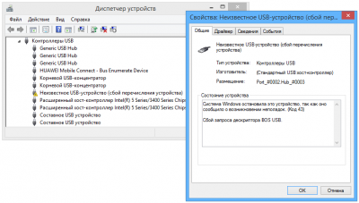
866 x 492 (28.88 KB)
Found a solution to this problem.
It turned out that in the HKEY_LOCAL_MACHINE \ SYSTEM \ CurrentControlSet \ Control \ usbflags registry key, you need to create a subsection 12D114430001, and in it the REG_BINARY SkipBOSDescriptorQuery parameter with the value 01 00 00:
#
Screenshot
Reduced by 48%
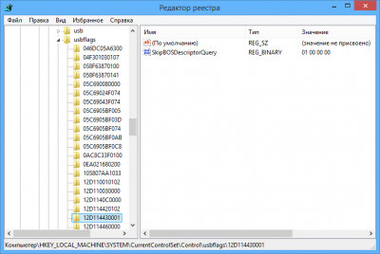
763 x 513 (28.86 KB)
To make the necessary changes to the registry, it is enough to run the reg-file from the BOS_solution_2.rar archive (307 bytes).
For Windows 8.1, the cumulative update KB2967917 should be installed in the system .

